[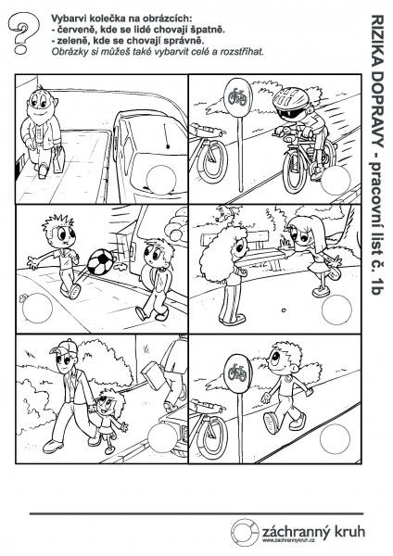](https://www.google.cz/url?sa=i&url=https%3A%2F%2Fcz.pinterest.com%2Fevaptkov%2Fdopravn%25C3%25AD-v%25C3%25BDchova%2F&psig=AOvVaw3lVQmTUmz2mzsEkEPJVMVb&ust=1587712413472000&source=images&cd=vfe&ved=0CAIQjRxqFwoTCMCLmOn__egCFQAAAAAdAAAAABAK)