**Clothes**

**Read the texts and draw the children's clothes.**

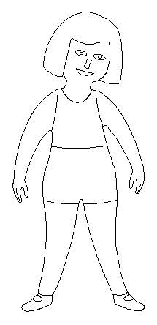 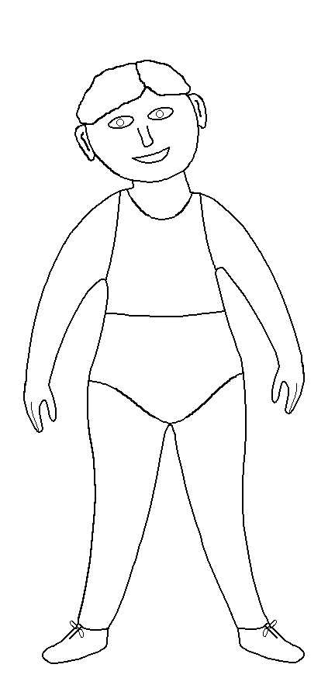

He wears grey trousers, a yellow shirt, brown shoes, purple socks and an orange cap.

She wears a pink skirt a blue t-shirt , white socks black shoes and a green hat.

**What are the animals wearing?**

**Die Maus trägt**

eien rosa Rock

ein grünes T-shirt

rote Socken

einen Hut



**The mouse is wearing :**

a red hat

a brown jacket

a geen t-shirt

red shoes

**The dog is wearing:**

shoes

an orange t-shirt

socks

grey trousers



**Der Hase trägt**

einen Hut

Einen grünen Pullover

grüne Schuhe

eine rote Hose

**The cat is wearing:**

**The bunny is wearing**

black boots

a red scarf

green trousers

a purple sweater

a dress

a green jacket

yellow trousers

white socks

**What do you wear when?**

|  |  |  |
| --- | --- | --- |
| it is hot and the sun is shining. --------------------------------------------------------------------------------------------------------------------------------------------------------------------  ----------------------------------------- | It is raining .  --------------------------------------  ------------------------------------  -------------------------------------  ------------------------------------  ----------------------------------- | It is snowing and very cold.  --------------------------------------  --------------------------------------  --------------------------------------  -------------------------------------- |

 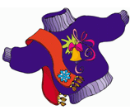 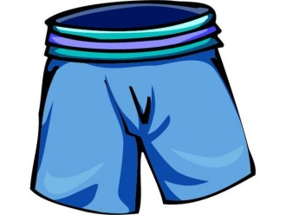 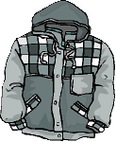

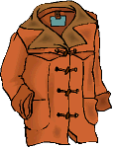 bluehat HH00808_ thongs 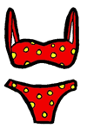

golfsocks 