What are they doing?



He ___________________________________ (write) on blackboard.

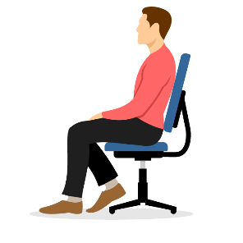She ________________________________(read).

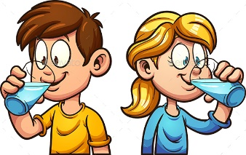He _____________________________(sit) on a chair.

They ___________________________________(drink).

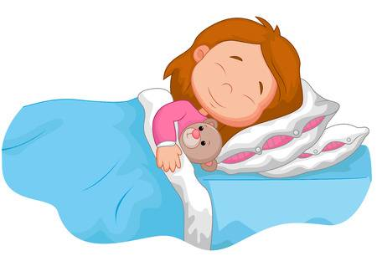

She ____________________________________(sleep).

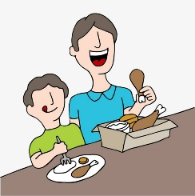

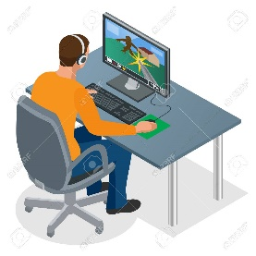 They _______________________________________(eat).

He ___________________________________(play) PC games.

They ________________________________________(swim).

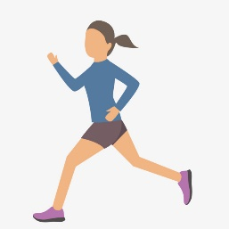

She _______________________________________(run).