[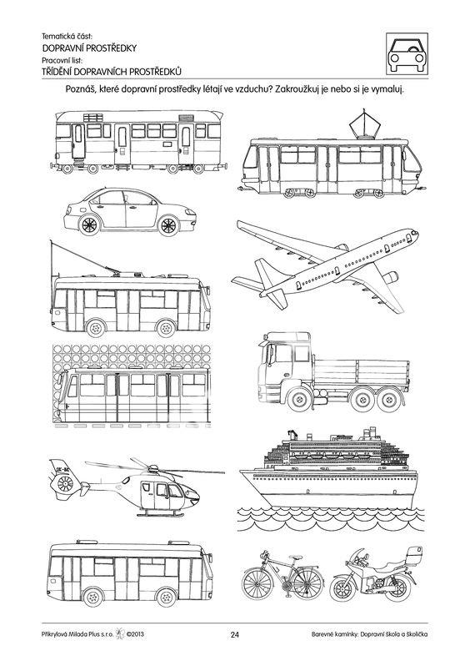](https://www.google.cz/url?sa=i&url=https%3A%2F%2Fwww.sevt.cz%2Fprodukt%2Fdopravni-skola-a-skolicka-soubor-pracovnich-listu-32016007605%2F&psig=AOvVaw3lVQmTUmz2mzsEkEPJVMVb&ust=1587712413472000&source=images&cd=vfe&ved=0CAIQjRxqFwoTCMCLmOn__egCFQAAAAAdAAAAABAX)